Master project in automatic controls and machine learning for the cryogenics systems at the European Spallation Source

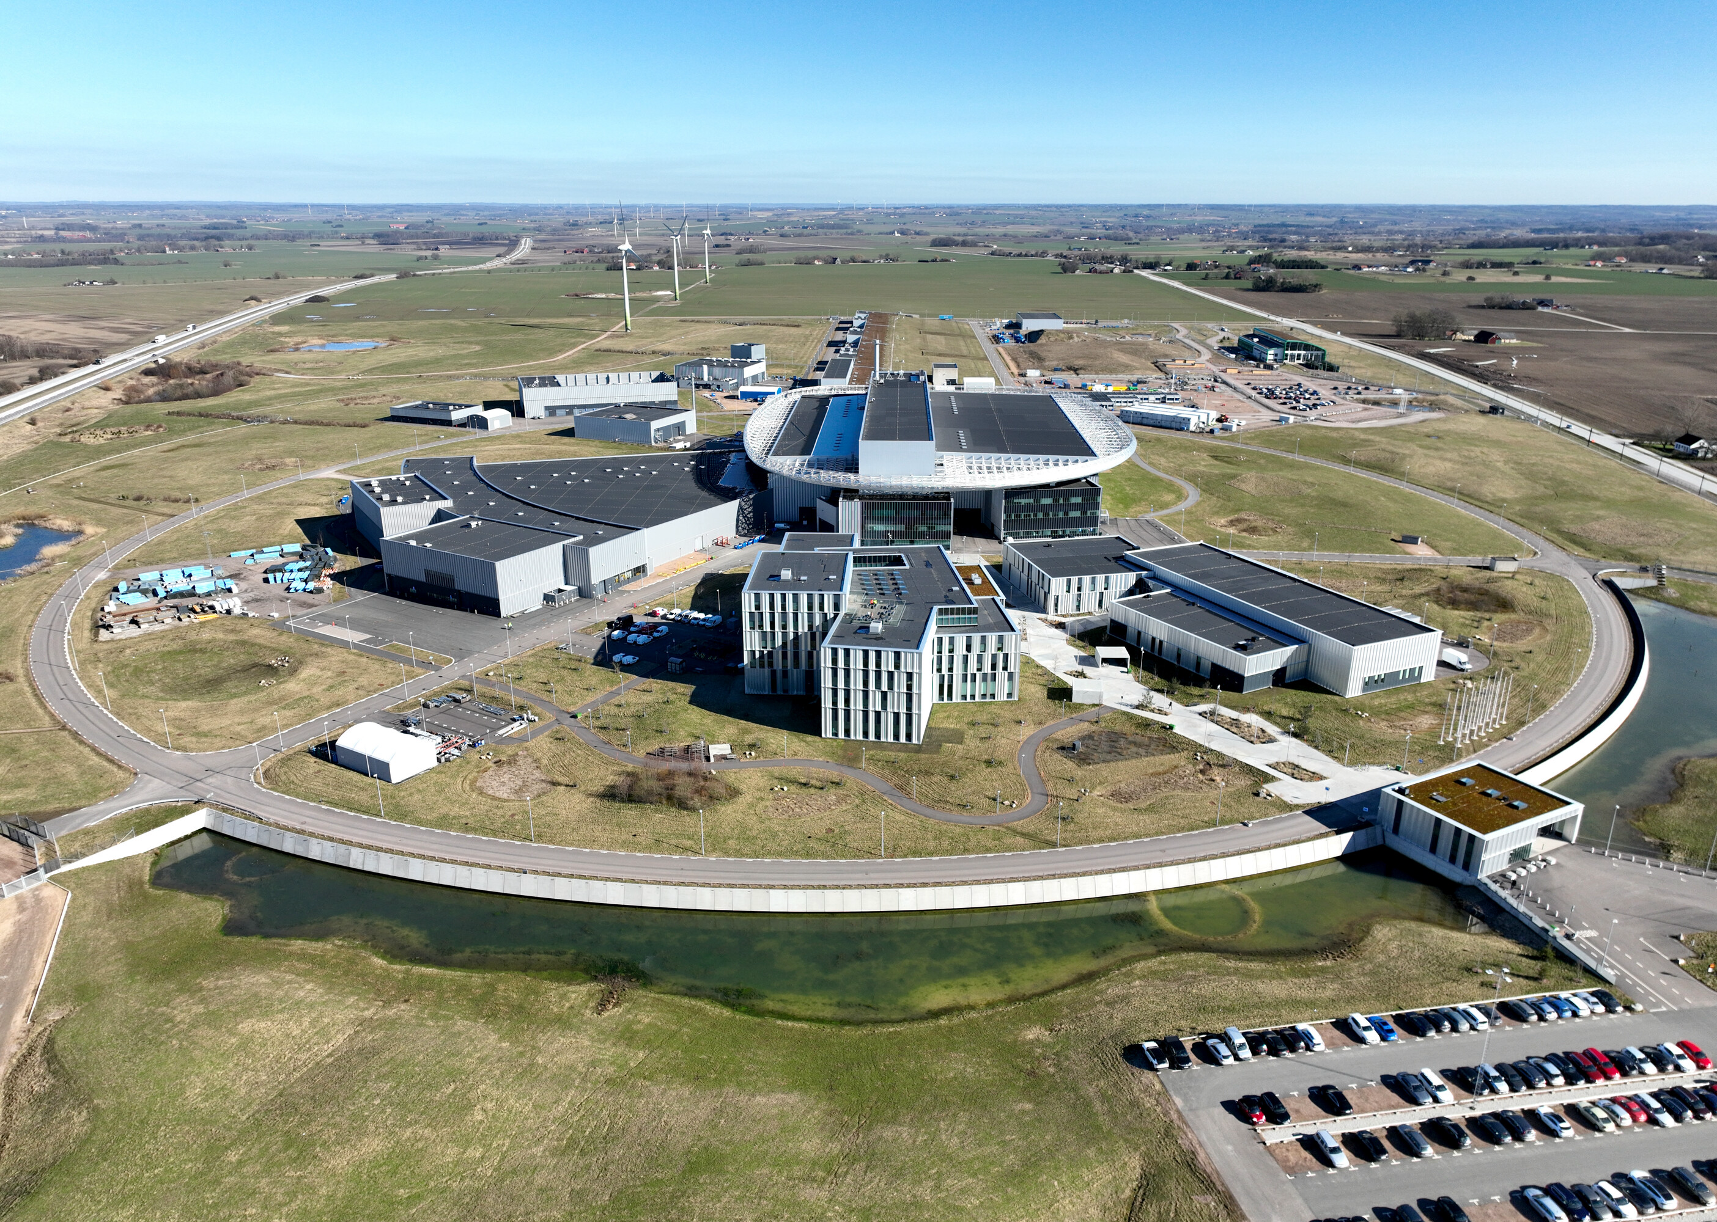

The cryogenic moderator system (CMS) at ESS is used to thermalize fast neutrons, a process that is vital for the experiments at ESS. Besides being an expensive and vital part of the facility, the CMS is also a critical system, since it circulates liquid hydrogen at 17 Kelvin and 12 bar.
While simulating cryogenic systems is very complex and time-consuming, a simulator is essential, since training operators, debugging control logic, and fine-tuning control parameters should be avoided in the live production environment.
Your task is to develop a simulator for a digital twin of the cryogenics system, based on measured data from the control system.
If you're interested in taking on this challenge and completing your master thesis project in automatic control at ESS, please get in touch with Karin Rathsman karin.rathsman@ess.eu or Attila Horvath attila.horvath@ess.eu.

